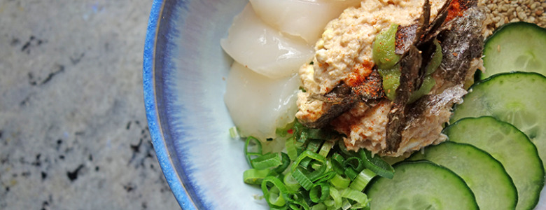

ITSU-STYLE, CRAB AND SCALLOP SUSHI BOWL

MARCH 16, 2015

In a city like London, there is no shortage of sushi to tempt any wasabi-loving foodie. However sushi isn’t cheap to have on the regular. Well certainly not if you have it as often as I do and there is the assumption that it is hard to make…

This is where my speedy, easy little sushi bowl comes in. I guarantee it will transform your weeknight suppers.

[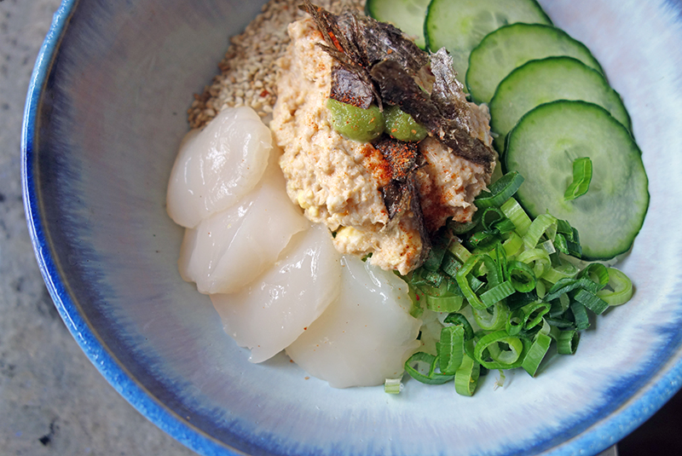](http://tessward.com/wp-content/uploads/2015/03/DSC00443.jpg)

I am sure you would agree, that dinner cooking time needs to be short on weekday. After long days of meetings a blood sugar crash can often make the prospect of preparing a more complex healthy weeknight dinners more than a little unappealing. If you are the sort of hardworking bunny that gets home late, or without much energy to cook, this is a recipe for you.

In case you weren’t sold already, the recipe is a total cheat and requires barely minutes to make. The only cooking is the rice and the rest is just a bit of chopping. Sound easy, well, it certainly is. For this recipe, I picked up a couple of super-fresh scallops from my local fishmonger and I bought a pre-dressed crab (if you can’t find a fishmonger, m&s do great ones, which are just the perfect amount for two.)

I can promise it will satisfy your cravings more that any on-the-go sushi, that you might be tempted to pick up on your way back. Better than a takeaway for the wallet and the tastebuds. Bonus points for those that use brown rice too, you’ve made it twice as healthy.

[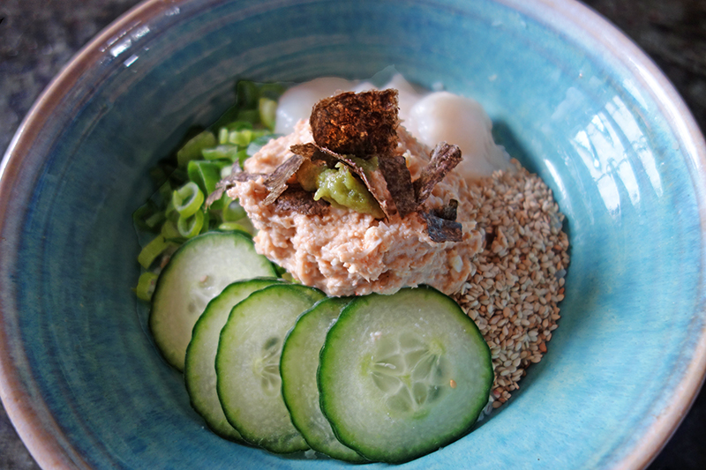](http://tessward.com/wp-content/uploads/2015/03/DSC00439.jpg)

**Spicy Crab and Scallop Donburi Bowl Recipe**

For those that aren’t so into raw seafood, you can cook the scallops. Simply sear each one in a hot frying pan with a little olive oil for a minute on each side and slice them in half (width ways) before serving.

Also, If you fancy mixing it up, you can try a few slithers of sushi-grade salmon arranged on top, or if raw fish isn;t your thing, another great topping is a handful of prawns seared in a frying pan and glazed in ginger and tamari.

I also advise doubling up the rice quantity and you can make this little beauty with different topping variations for a coupe of other nights in the week.

Serves 2

* 1 cup sushi rice (you can use white or brown)
* 1 tbs rice vinegar, 2 teaspoons honey and 1 tsp of salt
* 150g dressed crab
* 1/4 tsp chilli powder
* 2 large scallops, thinly sliced
* 2 spring onions, finely sliced
* 1/4 cucumber, sliced in thin disks
* 1/2 small sheet of nori, sliced/ripped into thin strips, to serve
* 2 tablespoons toasted sesame seeds

*To serve* : Wasabi, pickled ginger, soy sauce or tamari

[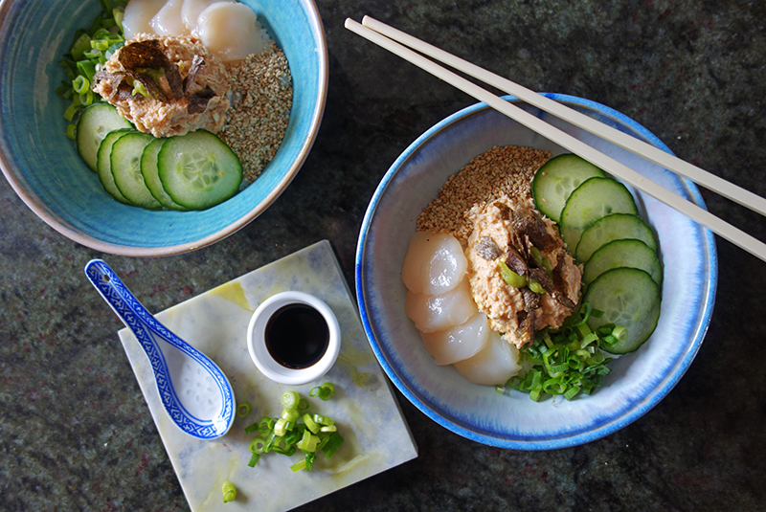](http://tessward.com/wp-content/uploads/2015/03/DSC00438.jpg)

Method

Rinse the sushi rice in a sieve until the water runs clear, then place the rice in a saucepan with the rice vinegar, honey and salt and cover with water by an inch (an inch and a half if it is brown rice) Bring the water to a boil, then reduce the heat to low, cover and cook for 20 minutes. The rice should be tender and all the water should be absorbed. Set aside the rice to cool until it reached room temperature.  (You can do this the night before and keep it in the fridge in tupperware until ready to use)

Mix the dressed crab with the chilli in a small bowl

Once the rice is cool, spoon the rice into bowls and arrange the garnishes on top.

Fan the cucumber, scatter the spring onions, place the sliced scallops and pour the sesame seeds around the bowl. Divide the crab between the two. Add a dollop of wasabi to each and top with the nori seaweed.

Serve with soy sauce and pickled ginger. Chopsticks optional, but try them if you need the practice.